An Analysis of the Front-end Web Development Involved in Arts and Media Websites

Abstract

In this paper, I will be analysing the front-end development involved in three arts and media websites.

I will be exploring the design of the pages, as well as how users navigate through the website. I will also be looking at how the sites deal with different devices and how their content changes to accommodate those using breakpoints. In addition, I will investigate how the sites change during use with the help of transitions and animations, and look at the code that employs this. Finally, I will check any technical errors there are and any extra features the site has.

Introduction

I have decided to analyse the front-end involved in these three arts and media websites: <http://i-d.vice.com/>, <http://www.dazeddigital.com/> and <http://www.thefader.com/uk> because firstly, they all display similar type of material to the users which means I can compare the way they present this material differently. Secondly, I like the simplistic stripped down design and wish to be able to create websites similar in design in the future. And Lastly, I think they all have quite interesting features to investigate further.

I-D (<http://i-d.vice.com/>)

I-D started in 1980 as a fashion magazine documenting the street style of punk-era London and has grown over the last 30 thirty years to incorporate different fashion, music , arts and the culture surrounding them (i-D, 2016). The website designed for the magazine has a clean and pleasing design utilizing the four basic design principles: proximity, alignment, repetition and contrast.

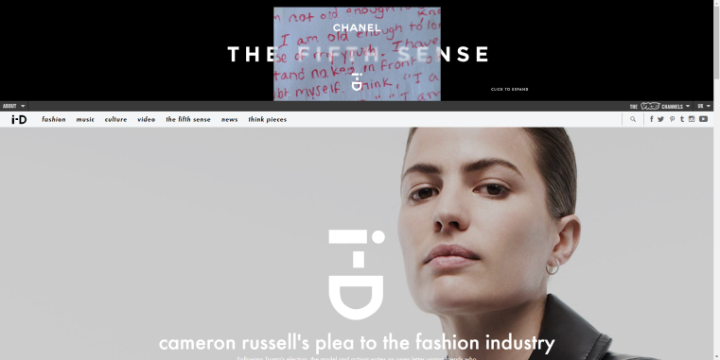

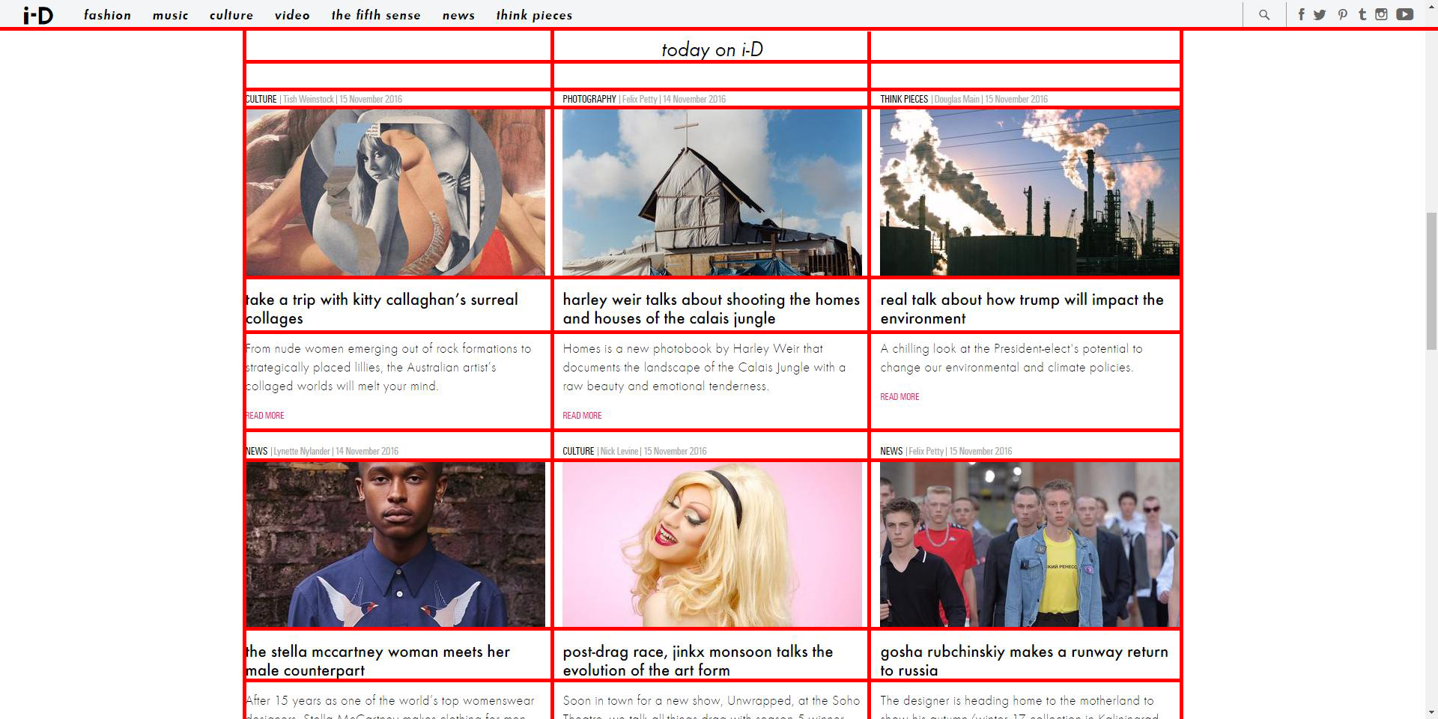

The two screenshots above show the most of the content on the I-D front-page. I have added red lines to show the grid alignment used which corresponds to the design principle.

Website Navigation and Usability

The first area of navigation I am drawn to on the I-D front-page is the menu-bar at the top of the page. The menu-bar itself is quite large with bold text and seven different options to explore, as well as a homepage button in the form of I-Ds logo, a search button, and social media buttons. When the user hovers their mouse over one of these seven menu items, a dropdown box appears and shows more menu options based on the original menu item hovered. Not every menu item has the feature however; I think it works really well. An example of this behaviour is shown below:

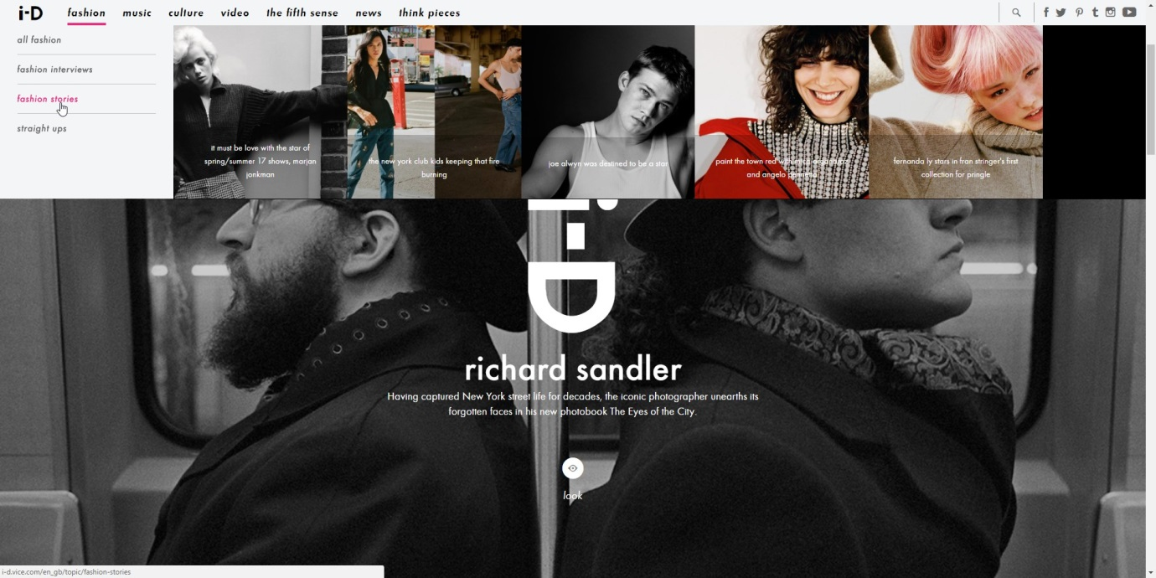

When the user hovers over one of these sub menu items the square images also change in the menu bar. These square images are clickable and link to the content they relate to. Even though I do like this style of menu-bar, there are some issues with the implementation of it. For example, I do not like the way that there is left over space at the end of the dropdown box just filled black. I understand that there is not enough space for another square image, but if there are more related articles, I think an improvement to this could be a scrolling image bar. I have illustrated this idea bellow:



I think this would be a much more elegant solution than just an empty space. Another issue I have found with this menu navigation bar is how long it takes to load. While navigating the website I found it took a few seconds to load the dropdown bar. However saying this, I do understand the website is heavily media focused and there are many large images involved.

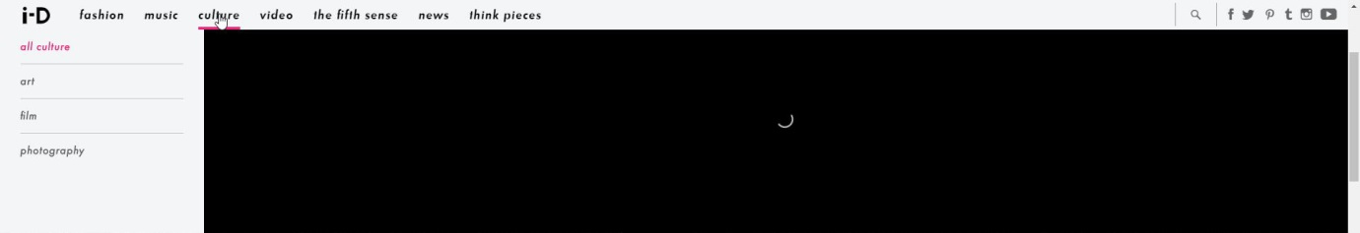

Looking at the implementation of this menu-bar in the source code, you can see that it is implemented using unordered lists encapsulated inside <nav>’s, encapsulated inside <div>’s. Inside a list item, there is one <a href=””> tag and a descriptive word that links you to the page it relates to. For instance <a href="/en_gb/topic/fashion"> fashion </a> line takes you to the fashion page.

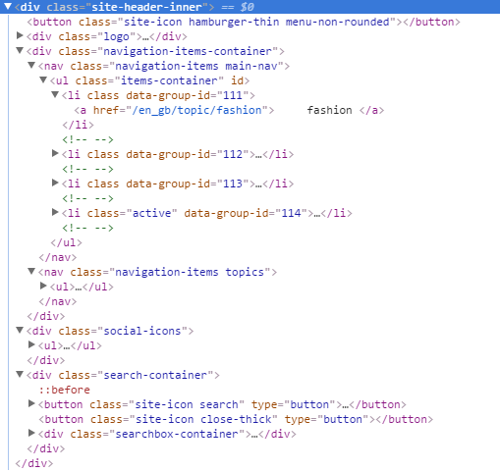

The HTML above only creates the actual menu-bar as it is when you load the page. The HTML bellow however creates the dropdown area of the menu-bar, which will expand to when the mouse is hovered over.

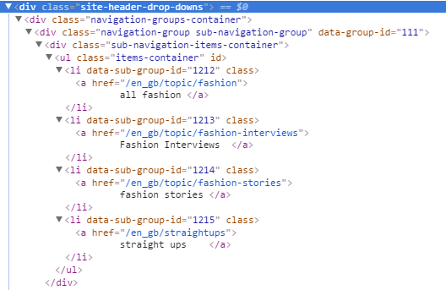

To get the menu-bar to work as it should, there is CSS to make the dropdown part only appear when it is meant to. While inspecting the menu this is the code before me moving my mouse over the “fashion” button:

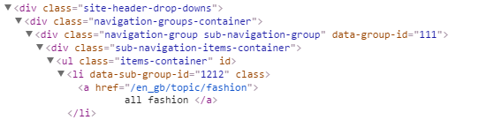

And this is the code while my mouse is hovered over the “fashion” button:

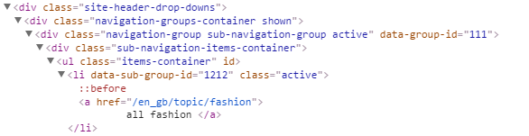

The second line of code is the first to change. Now the selector ”shown” has appeared. This enables specific CSS can be applied when the mouse is over the “fashion” button. The specific CSS that is applied when is happens is:

http://i.imgur.com/MGkXVrv.png

This changes the opacity of the content from 0 to 1 and changes the top value to 100% from negative 18rem so the content can be seen.

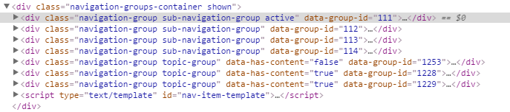

This next chunk of code shows all seven of the menu items to help illustrate what happens when you mouse over one of them. In this case it is the first one, “fashion”. The selector ”active” has appeared which means that you can select and style the specific link in CSS (W3schools.com, 2016). For instance, this next selection of CSS changes the display type to block and the opacity to 1:

http://i.imgur.com/4coMc5j.png

In this case, setting display to block makes the whole area a link, not just the text.

Breakpoints

“Breakpoints are the point at which your sites content will respond to provide the user with the best possible layout to consume the information“(ResponsiveDesign.is, 2016). This is done by applying specific CSS when the size of your media changes. For instance changing how a website is viewed on your desktop compared to your phone. However, there are usually many breakpoints on a webpage to keep the content looking the best it can in the canvas the page is given.

Here is an extreme example of how a breakpoint is used on I-D from a full sized desktop screen to an IPhone 5s screen:

Desktop (1920x960) IPhone 5s (640x920)



As you can see, the content has changed quite dramatically to fit the screen on a mobile phone compared to the desktop. For example, the menu bar at the top is now a dropdown menu, instead of describing the article on the picture itself, the description is now under the image and there is no longer a grey translucent filter on the image. This grey filter is no longer needed, as the white text is no longer on the image.

On the I-D webpage, there are many more breakpoints involved in keeping it working well and looking good. I have counted 16 separate breakpoints on I-D that make sure of this. The specific code involved in the implementation of breakpoints on I-D is shown below:

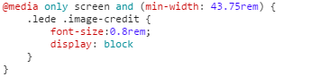

This chunk of code is only one example of how part of a breakpoint on I-D is implemented and there are many more specific parts of the CSS that apply to this screen size. One complaint I would have about the I-D CSS is that some parts of the code that apply to the same screen size are in different areas of the code. For example, there would be one @media tag for screen size of 43.75rem followed by three for a screen size of 62.5rem and then back to 43.75rem. It would be much easier to see how a breakpoint is implemented if they were grouped. For instance, there are 278 separate @media tags and looking through these in a random order is not very efficient. Not having them grouped is also a concern as this could mean that there is repeating chunks of code as it would be hard for a developer to tell.

User Interaction Animations & Transitions

The I-D website has many subtle animations and transitions throughout the site. Even when resizing the browser and activating a breakpoint, there is a transition that makes the I-D logo in the centre of the homepage gradually resize to fit the page.

There is also an animation with the menu-bar. When the user places their mouse over one of the menu items, the relevant dropdown menu slides out of the bar. I think this works well however the area that slides out from the menu bar is just a black box until it reaches the size of the dropdown menu when the content pops in. I think an improvement would be to make the content come out as it is meant to be as I think it would be more satisfying, however it may be more demanding and could load slower for some users. The code that implements the transition on the menu-bar is below (the crossed out lines mean the line of code has been overridden):

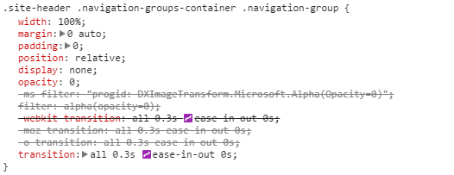

One more area of the webpage that has an animation is the article teasers on the front-page. These help indicate to the user when they can click on an area that will take them to the article. I think these work well on the page. This transition also has a transition time of 0.3 seconds.

 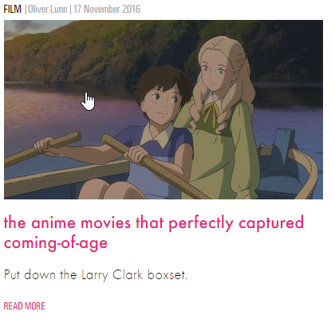

Technical Issues

According to the World Wide Web Consortium’s (W3C) HTML validation tool, there are ten errors in the HTML on the I-D website (Validator.w3.org, 2016). I was surprised to find that two of these errors are just stray end tags, which are not a huge issue and easily fixed. However, there is one fatal error, which implies there may be more errors in the code but the validator cannot continue because of this error.

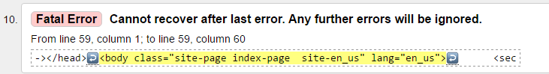External APIs, Frameworks and Libraries

To find out the different technologies implemented into the site I chose to use an online tool (BuiltWith, 2016). From this tool, you can see I-D is running on the web server NGINX, which is currently the second most popular web server around with 27% of the most popular websites using it (Trends.builtwith.com, 2016).

In terms of website analysis programs, there are eight different analysis technologies running on I-D currently. They all provide various different helpful things to the company. For example, one of them, Chartbeat, collects audience-behaviour data showing how users are engaging with the site right now, as well as showing the real-time traffic on the site (Chartbeat.com, 2016). Another one of them called Krux Digital, captures, connects and monetizes consumer data on the site (BuiltWith, 2016). In addition, Google analytics is also running on I-D, which helps analyse the site traffic as well as helping the company learn about their audience (Analytics.google.com, 2016).

Most of the other technologies involved in the site are social interaction centric, such as social media widgets and RSS integration, however, there is a JavaScript library Modernizer being used (BuiltWith, 2016). Modernizer is used to check what browser the visitor of the site is using and alter the CSS accordingly. This means that if the web browser the visitor is using is does not support the features the website accommodates, fixes can be put in place (Leadbetter, 2016).

Dazed & Confused (<http://www.dazeddigital.com/>)

Dazed & Confused magazine was created to show alternative style and culture in 1991 (Dazed, 2016) and has grown to an online platform where many of their articles are now published. Similarly to I-D, this site has a menu-bar and then one large image article bellow. However, on this site the article changes between five main articles every six seconds with a transition. There is also an advertisement above the menu-bar at the top of the page like I-D, but there are also advertisements to the sides of the pages in addition. I think this style of showing sponsored content is a little overwhelming and may off-put some users. For comparison, I have taken a screenshot of the original homepage, and the homepage with an advertisement blocker enabled (Other pages on the site are not as advertisement heavy):

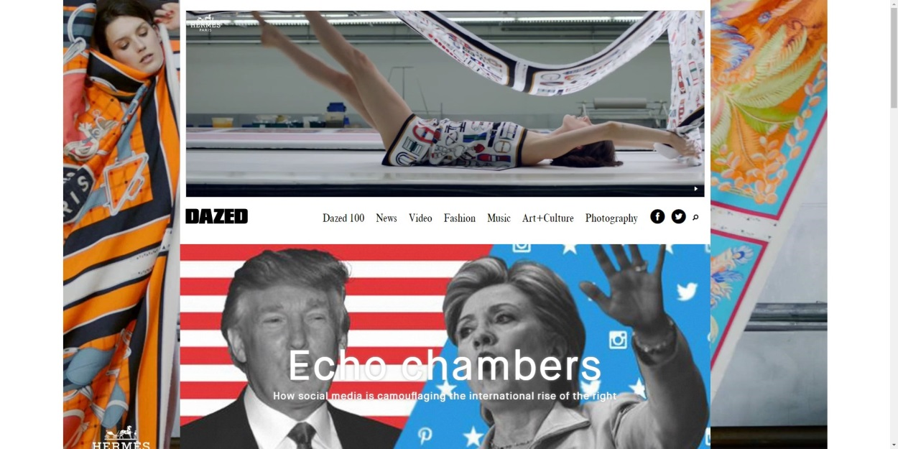

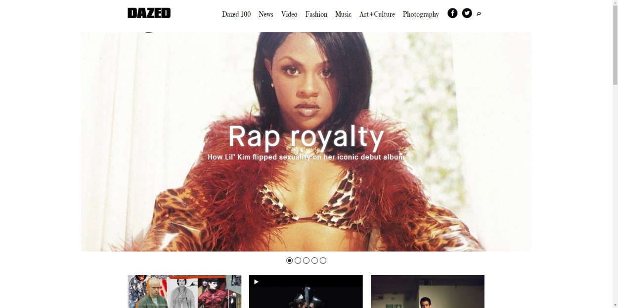

Website Navigation and Usability

The first thing you see when opening Dazed & Confused is the large article in the centre of the page. There are transitions between five main articles with six seconds between transitions. The user can also click through the articles themselves. I think this works well and adds something moving to the page, which could interest readers.



The second area of navigation I am drawn to is the menu-bar. Unlike I-D, there is no dropdown menu at all. The design is kept very straightforward and clean with only a single black line underlining the menu item you are hovering over.

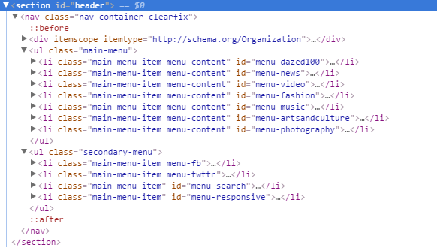

The HTML for the menu-bar shows another difference to I-D’s. Instead of using a collection of <div> tags and a <nav> tag, the developers of Dazed & Confused decided to use a <nav> tag inside a <section> tag. The difference between these two elements <div> and <section> is that <section> represents a generic section of a document (Dev.w3.org, 2016) and is used to group content, a <div> however, has no special meaning at all and represents its children (Dev.w3.org, 2016).

This menu-bar on this site is much simpler, and does not need as much encapsulation of elements as there is no pop out area involved. The menu itself is split into two areas on this site, main-menu and secondary-menu. The main-menu has seven different menu items; they include “Dazed 100”, “News”, “Video”, etc. The secondary-menu includes four items, two social media buttons, a search button and a responsive button (only shows when a certain breakpoint is met).

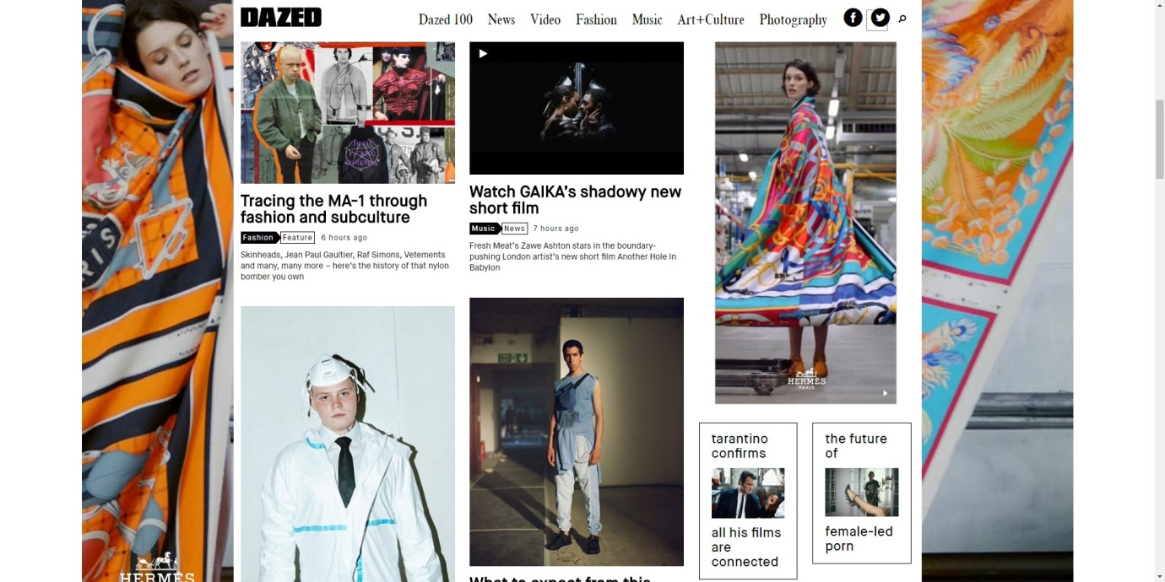

Another area of navigation the users will interact with are the article teasers under the main article images. These are laid out in a different way to I-D’s also with a more of a collage style. I quite like the look; however, it does look a little messy in my opinion.

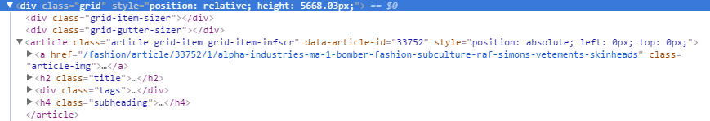

The code above relates to the first article in the top left of the screen shot. Similarly to the menu-bar, the main content of the page it also encapsulated inside a <section> tag. The articles are also positioned absolutely, with a position in pixels described. This seems to me like it may be much more difficult to update the front-page of the site and change the articles. There would need to be more tweaking to make sure the page still looks appealing. The articles are in a grid structure however, which would save time.

Breakpoints

Desktop (1920x960) IPhone 5s (640x920)

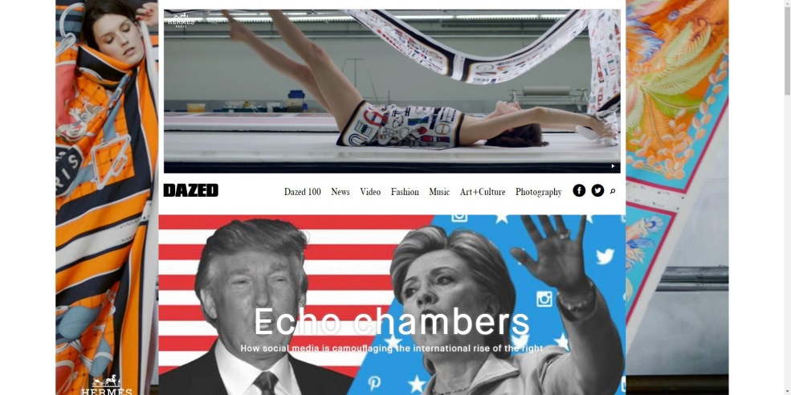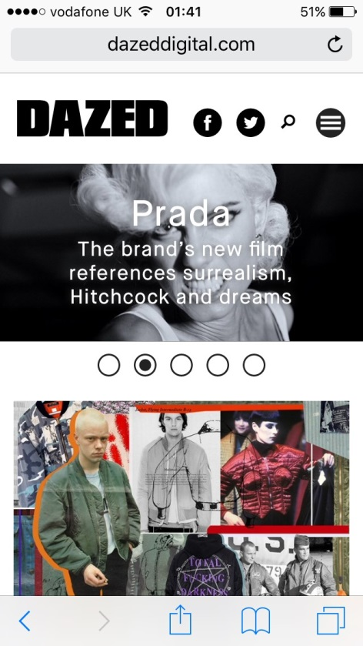

As you can see from the two screenshots above and to the right, there is a dramatic difference between the desktop version of the site and the mobile version. Like discussed earlier this is due to breakpoints. The main changes are that the menu-bar has now turned into a dropdown menu. This is the menu-responsive list item in the menu code that was not showing before.

The code for these breakpoints are structured in very similar way to I-D, however here they use the !important declaration. This seems like a way to fix mistakes in the code, as it is not needed. It could have been used to just make sure the CSS is overridden.

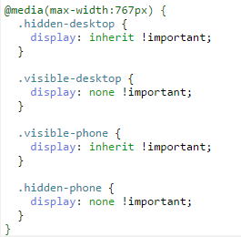

User Interaction Animations & Transitions

The only major transitions on Dazed & Confused are the ones between the main articles on the homepage.

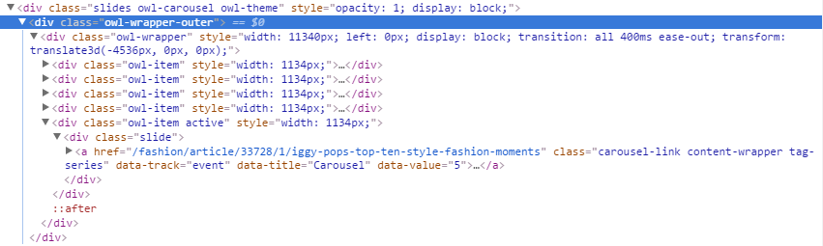

As you can see, a 400millisecond transition moves one image link to another. You can also click to see the image you want to see by clicking on the circles bellow them. As you can see the active selector is also used once again:

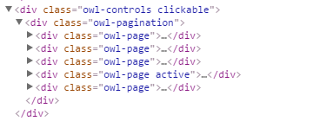

Technical Issues

Analysing the website with the W3 validation tool (Validator.w3.org, 2016), I found there were eight errors and eight warnings. However, seven of these errors are Duplicate ID errors and the warnings relate to them.

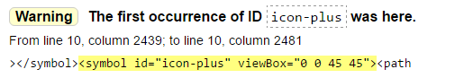

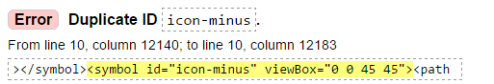

This could be a problem as there could be overwritten code if an ID has been used twice, as well as repeating code.

External APIs, Frameworks and Libraries

Dazed & Confused is running on ASP.NET MVC framework (BuiltWith, 2016). ASP.NET MVC is a framework that is a ”lightweight, highly testable presentation framework” (Msdn.microsoft.com, 2016).

Similarly to I-D, this site uses many different analysis plugins and widgets. However, there are much more JavaScript libraries used such as jQuery and the Facebook SDK.

This site also has CSS media queries to help with accommodating to all devices and browsers.

The FADER (<http://www.thefader.com/uk>)

The FADER founded in New York in 1999 was originally also just a magazine. This time however the focus was more on music. (Frank et al., 2016) Now the FADER’s content shows a range of music, style and culture articles.

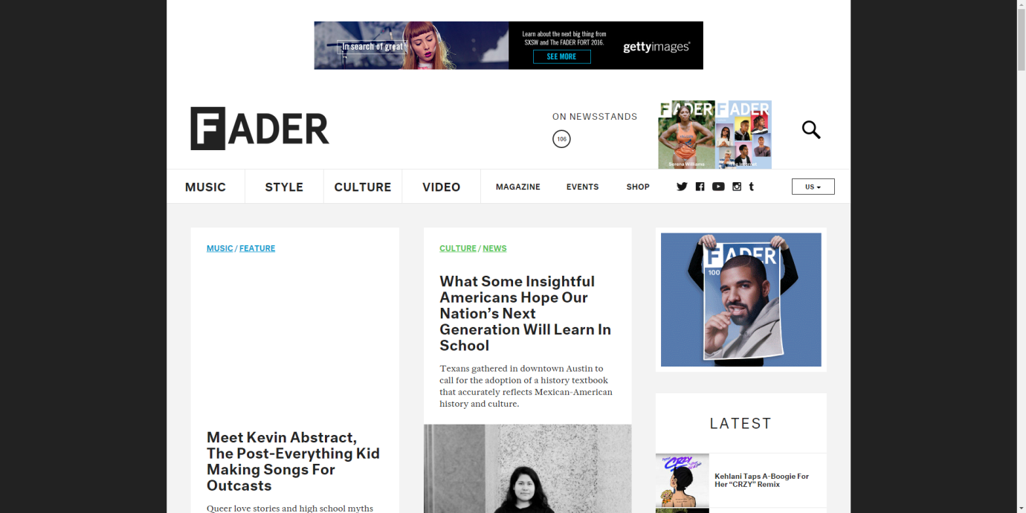

Website Navigation and Usability

The design of The FADER’s website is the most different out of the three sites I am analysing. This time there is no big cover photo when you open the site; instead, you get strait to the articles. The first area of navigation is the menu-bar once again:



This menu-bar is similar to the Dazed & Confused menu-bar in the fact that it is split into two sections, however it is implemented using <div>’s not <section> like I-D. The first section has the four major links and the second has the smaller items as well as the social icons.

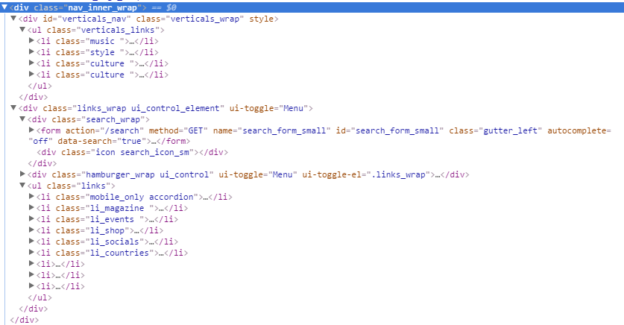

Error

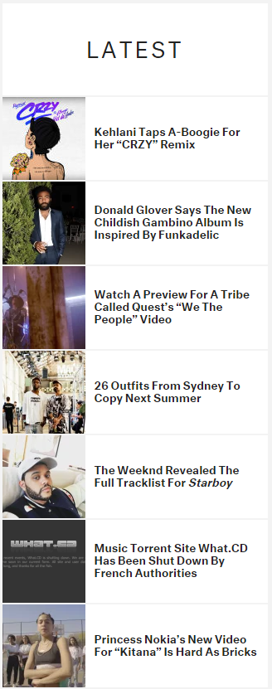Another area of navigation on The FADER is the latest bar (right). This shows the most recent content on the site. This time the <section> tag is used to group the elements together. The HTML for the latest bar is below:

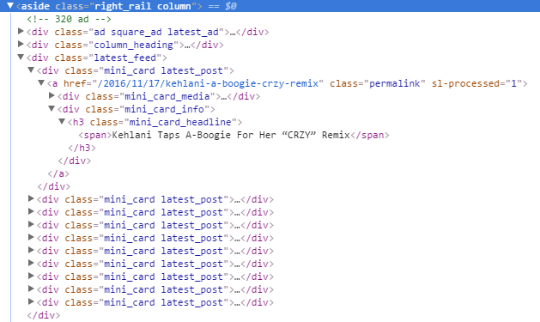

Breakpoints

Desktop (1920x960) IPhone 5s (640x920)

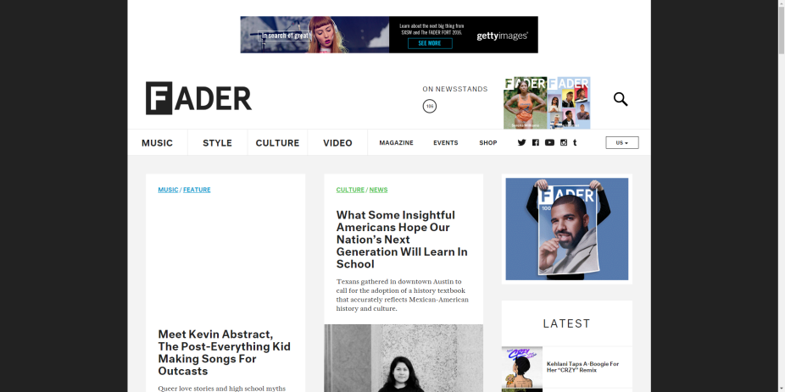

The FADER has a similar behaviour when it comes to being responsive and implementing breakpoints. As you can see, the change is quite dramatic. The latest and trending bars have moved to the top where the original menu items were, and the original menu items have been placed in a dropdown menu.

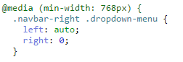

The CSS is again very similar, however there is no !important like Dazed & Confused.

User Interaction Animations & Transitions

The only transitions on The FADER are the changing of text style and colour when hovered over. For instance, every main menu item is underlined and given a colour (except video as it shares a class with culture – error):



This feature is applied through the site with the same effect shown when hovering over an article.

Technical Issues

The first issue I immediately noticed was the lack of content on the homepage. One of the articles failed to load an image for me. I refreshed and still the same outcome.

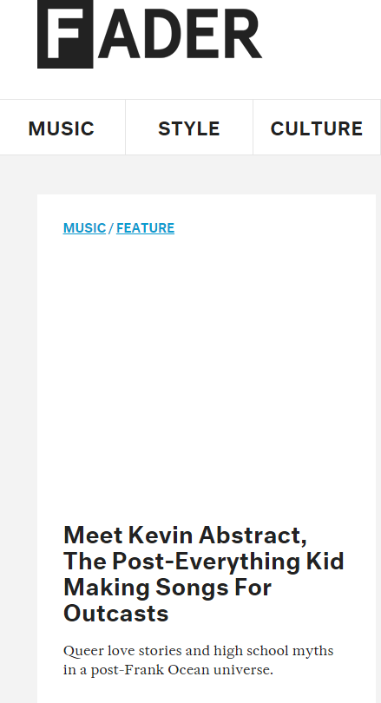

The second issue was something I noticed while looking through the HTML for the menu-bar. Two of the menu items have the same class ”culture”. The most obvious effect of this is that the two menu items, when hovered over, have the same colour.

Using the W3 validator (Validator.w3.org, 2016) eight errors were found. However, a fatal error was found stopping more errors from being discovered.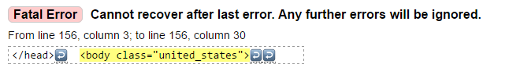

External APIs, Frameworks and Libraries

The FADER has the heaviest use of external technology with a similar group of analytics, tracking and advertising technologies (BuiltWith, 2016). However, The FADER also implements the Bootstrap framework for the CSS.

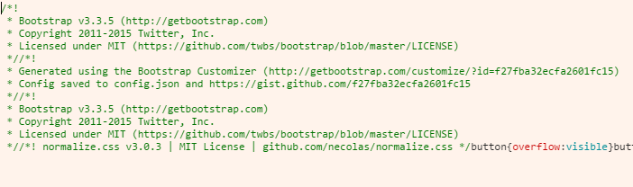

Bootstrap is the most popular framework for HTML, CSS and JavaScript there is for developing responsive, mobile-first web sites (W3schools.com, 2016). Mobile-first means that the site is designed first for mobile and then breakpoints are introduced when they are needed.

Bibliography

Analytics.google.com. (2016). *Redirecting...*. [online] Available at: https://analytics.google.com/analytics/web/provision/?authuser=0#provision/SignUp/ [Accessed 17 Nov. 2016].

BuiltWith. (2016). *DAZEDDIGITAL.COM Technology Profile on BuiltWith*. [online] Available at: https://builtwith.com/dazeddigital.com [Accessed 18 Nov. 2016].

BuiltWith. (2016). *I-D.VICE.COM/EN_GB Technology Profile on BuiltWith*. [online] Available at: https://builtwith.com/?http%3a%2f%2fi-d.vice.com%2fen_gb [Accessed 17 Nov. 2016].

BuiltWith. (2016). *THEFADER.COM/HOME Technology Profile on BuiltWith*. [online] Available at: https://builtwith.com/?http%3a%2f%2fwww.thefader.com%2fhome [Accessed 18 Nov. 2016].

Chartbeat.com. (2016). *Web Analytics for Everyone | Chartbeat*. [online] Available at: https://chartbeat.com/personal/ [Accessed 17 Nov. 2016].

Dazed. (2016). *Dazed & Confused*. [online] Available at: http://www.dazeddigital.com/info/article/824/1/dazed-confused [Accessed 13 Nov. 2016].

Dev.w3.org. (2016). *4.4.2 The section element — HTML5*. [online] Available at: https://dev.w3.org/html5/spec-author-view/the-section-element.html#the-section-element [Accessed 17 Nov. 2016].

Dev.w3.org. (2016). *4.5.13 The div element — HTML5*. [online] Available at: https://dev.w3.org/html5/spec-author-view/the-div-element.html#the-div-element [Accessed 17 Nov. 2016].

Frank, A., D. McDermott, P., Patel, J., Roberts, S. and Zeichne, N. (2016). *I Trust You: The Oral History Of The FADER*. [online] The FADER. Available at: http://www.thefader.com/2015/09/29/fader-oral-history-100 [Accessed 13 Nov. 2016].

i-D. (2016). *About | i-D*. [online] Available at: http://i-d.vice.com/en_gb/about [Accessed 13 Nov. 2016].

Leadbetter, T. (2016). *Using Modernizr to detect HTML5 features and provide fallbacks | HTML5 Doctor*. [online] Html5doctor.com. Available at: http://html5doctor.com/using-modernizr-to-detect-html5-features-and-provide-fallbacks/ [Accessed 17 Nov. 2016].

Msdn.microsoft.com. (2016). *ASP.NET MVC Overview*. [online] Available at: https://msdn.microsoft.com/en-us/library/dd381412(v=vs.108).aspx [Accessed 18 Nov. 2016].

ResponsiveDesign.is. (2016). *Defining Breakpoints*. [online] Available at: https://responsivedesign.is/strategy/page-layout/defining-breakpoints [Accessed 13 Nov. 2016].

Trends.builtwith.com. (2016). *Web Server technologies Web Usage Statistics*. [online] Available at: https://trends.builtwith.com/web-server/ [Accessed 17 Nov. 2016].

Validator.w3.org. (2016). *Showing results for http://i-d.vice.com/en_us - Nu Html Checker*. [online] Available at: https://validator.w3.org/nu/?doc=http%3A%2F%2Fi-d.vice.com%2Fen_us [Accessed 15 Nov. 2016].

Validator.w3.org. (2016). *Showing results for http://www.dazeddigital.com/ - Nu Html Checker*. [online] Available at: https://validator.w3.org/nu/?doc=http%3A%2F%2Fwww.dazeddigital.com%2F [Accessed 18 Nov. 2016].

Validator.w3.org. (2016). *Showing results for http://www.thefader.com/home - Nu Html Checker*. [online] Available at: https://validator.w3.org/nu/?doc=http%3A%2F%2Fwww.thefader.com%2Fhome [Accessed 18 Nov. 2016].

W3schools.com. (2016). *Bootstrap 3 Tutorial*. [online] Available at: http://www.w3schools.com/bootstrap/ [Accessed 18 Nov. 2016].

W3schools.com. (2016). *CSS :active Selector*. [online] Available at: http://www.w3schools.com/cssref/sel_active.asp [Accessed 17 Nov. 2016].